

Alexandria University

Faculty of Engineering

Electronics and Communication Department



Ahmed SamehTaha 21010083

Amir Mohamed Kasseb 21010302

`

**Signals & Systems**

Lab (1) Report

**By**

**Supervised by:**

Eng. Ahmed Mostafa

Eng. Esraa Ragab

Problem 7

1. 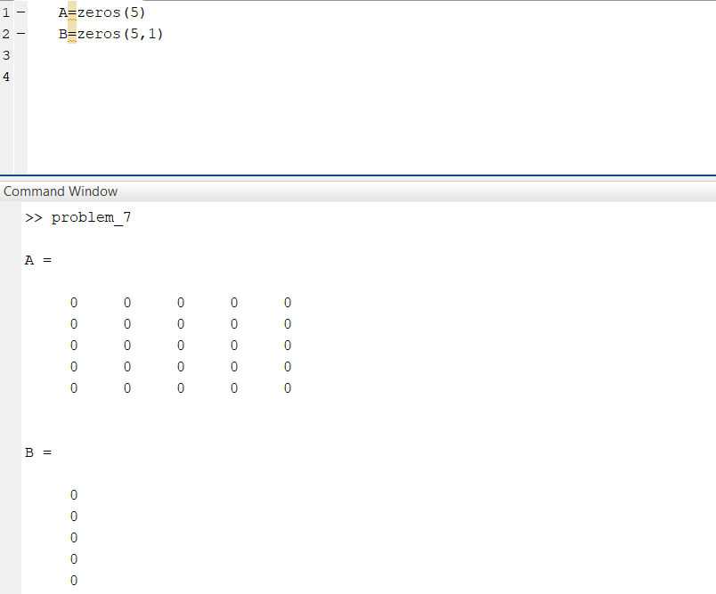Use the ‘zeros’ function to create an empty 5 -by-5 matrix (A) for the coefficients and an empty 5 -by-1 column vector (B) for the RHSs of the equations.



1. 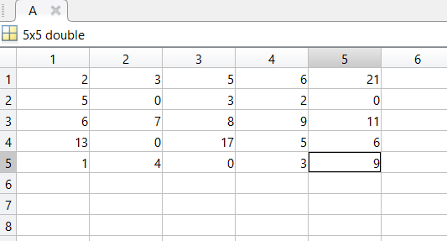Use the array editor to populate the coefficients into matrix (A).
2. 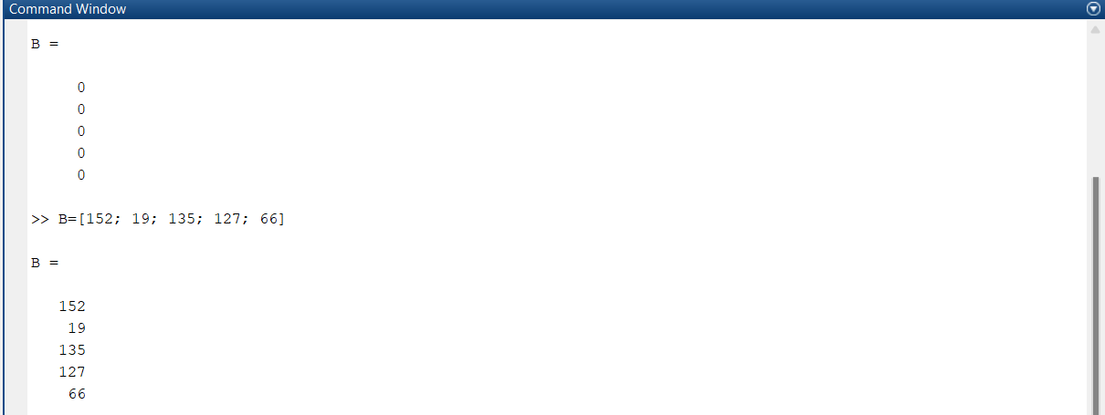Use the command prompt to populate the RHSs into vector (B).
3. we can use the ‘rank’ function to find out whether or not the 5 equations are “independent” enough to assign unique solutions for the 5 unknowns, by Comparing the rank & the number of unknowns.

If the rank is equal to 5, it means that the system of equations has a unique solution. If the rank is less than 5, the equations are dependent, and the system may have infinite solutions or the system is inconsistent.

1. Write down an expression for a variable S that is true if the rank of (A) is equal to the number of variables in the case above and false otherwise.

By using size(A, dim), where A is the matrix and dim specifies the dimension which is 2D Matrix.

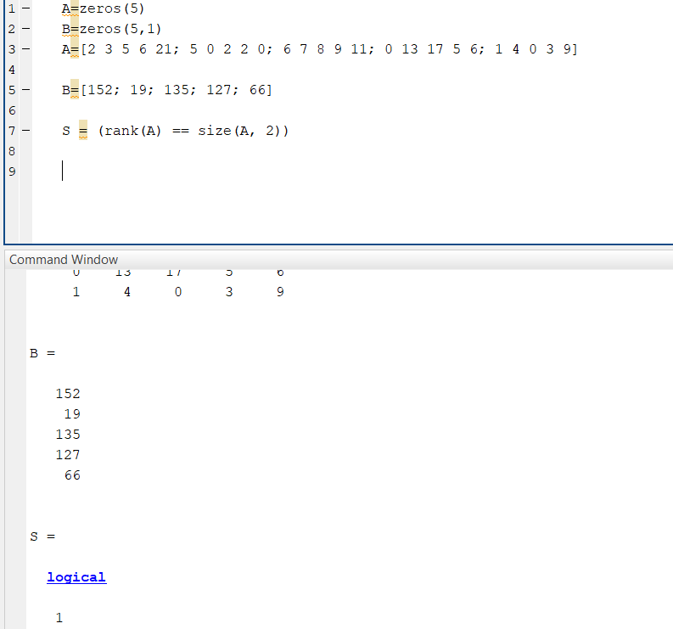

1. 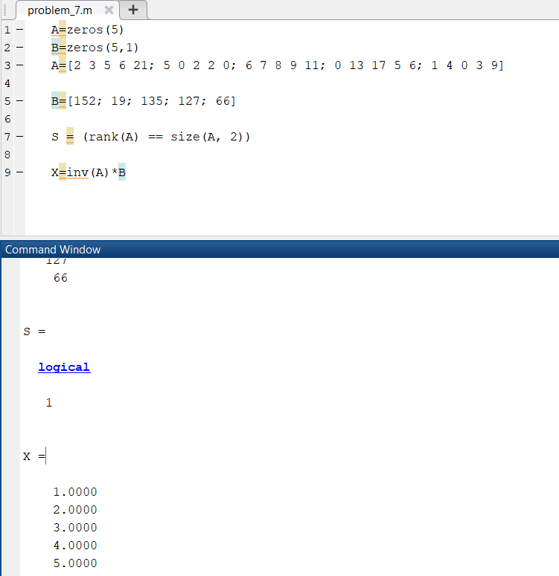Solve the set of linear equations for x1 through x5.

AX=B

X=inverse of A * B